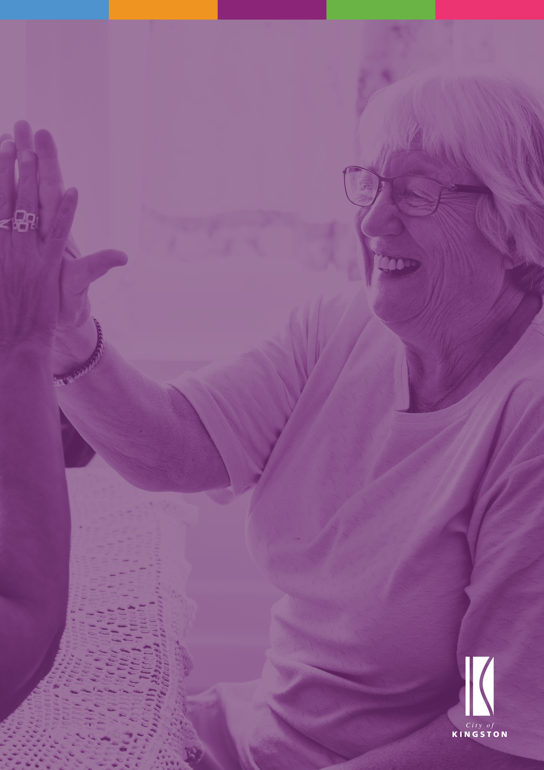

|  |
| --- |
| Positive Ageing Plan |
| 2022-2026 |
|  |

­

*An action plan of the City of Kingston’s Public Health and Wellbeing Plan 2021 – 2025*

Acknowledgement of Country

The City of Kingston recognises the Bunurong people as the Traditional Custodians of the land on which the municipality is a part. We pay our respect to their Elders past, present and emerging, and to all Aboriginal and Torres Strait Islander peoples who call Kingston home. Their enriched knowledge and wisdom of our land and waterways is an essential part of the culture of our community.

Contents

1. Introduction 4

2. Supporting Positive Ageing 4

3. Actions 8

Goal 1. A healthy and well community 10

Goal 2. A safe and secure community 10

Goal 3. A kind and connected community 11

Goal 4. A liveable community 12

Goal 5. An informed and empowered community 13

4. Background information 14

Legislative and policy context 14

Data and demographic profile 14

How we developed the Positive Ageing Action Plan 2022-2026 15

How we will implement the Positive Ageing Action Plan 2022-2026 16

How we will monitor the Positive Ageing Action Plan 2022-2026 16

1. Introduction

The Positive Ageing Action Plan 2022-2026 is a strategic document that will support Council to continue to strengthen its response to the needs and aspirations of older people. It has been developed to support the application of Council’s Public Health and Wellbeing Plan 2021-2025 (PHWP 2021-2025).

The Action Plan outlines key priorities and actions to be implemented over the next four years. The overall implementation of the actions will be managed by the Social Development Team with the support and collaboration of other departments across Council and with key community organisations, groups, and agencies. Key achievements will be reported to Council and the community on an annual basis.

2. Supporting Positive Ageing

Guided by the COMmunity vision and Council plan 2021-2025

The Positive Ageing Action Plan 2022-2026 aligns with the Council Plan Community Vision:

**Community Vision**

Kingston is a resilient, inclusive and diverse community. We are building the most liveable and sustainable city in Victoria.

We champion and nurture our green and open spaces creating a safe, healthy environment.

Our shared legacy connects our community, embracing innovation, making Kingston the place to live.

**Council Plan 2021-2025**

The Positive Ageing Action Plan 2022-2026 is also strategically guided by the Council Plan 2021-2025 and aligns as follows:

Strategic Direction: Healthy and Inclusive

Strategic Objective: We are progressive, inclusive and prioritise the wellbeing of all members of our community.

Strategies: Champion social equality

Support community education, lifelong learning and creativity

Support the inclusion of everyone in community life

Support our community’s physical wellbeing

Prioritise our community’s mental wellbeing

Tailor our communication to our diverse community to make communication accessible to all.

Guided by Council’s Public Health and Wellbeing Plan 2021-2025

The PHWP 2021-2025 provides an overarching strategic direction that identifies key health and wellbeing priorities for Kingston. ThePositive Ageing Action Plan 2022-2026 will contribute toward the delivery of the following goals of the PHWP 2021-2025:

**Goal 1:** A Healthy and Well Community

**Goal 2:** A Safe and Secure Community

**Goal 3:** A Kind and Connected Community

**Goal 4:** A Liveable Community

**Goal 5:** An Informed and Empowered Community

The Positive Ageing Action Plan 2022–2026 will incorporate a collaborative approach in the shared delivery of the goals of the PHWP 2021-2025. This will occur by integrating other Council Plans and Strategies that deliver on the priorities of the PHWP 2021-2025 in the implementation, measurement, and evaluation of actions.

There is a range of action plans and strategies across Kingston Council that deliver the priorities of the PHWP 2021-2025. The combined outcomes of the actions will improve the health and wellbeing of the Kingston community. The action plans that have direct alignment and operate on the same four-year cycle are listed below:

**Figure 1:** Public Health and Wellbeing Plan and aligned Action Plans

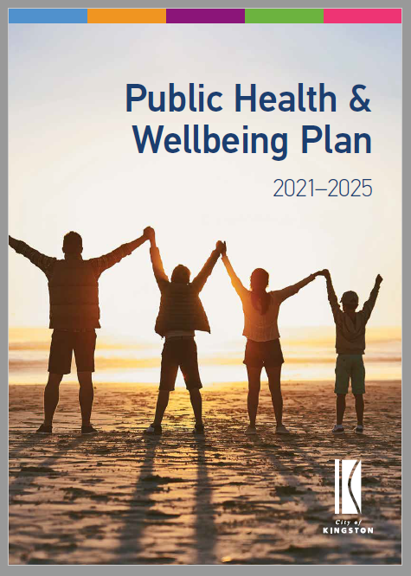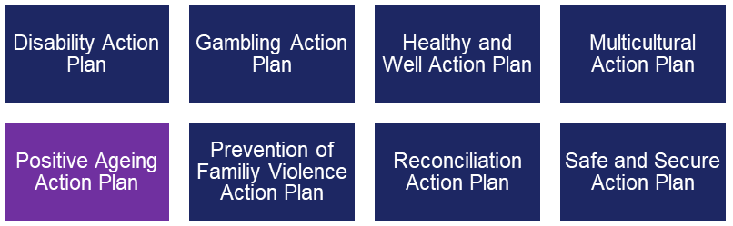

Public Health and Wellbeing Plan 2021-2025: GOALS and Objectives

Kingston’s PHWP 2021-2025 provides a strategic direction for Council’s actions to improve the health and wellbeing of the community. The goals and objectives of the PHWP outline how we will all work towards addressing these factors.

The PHWP goals and objectives are outlined below, with the objectives relevant to this Plan identified:

|  |  |
| --- | --- |
| **PHWP Goal / Objective** | **This Action Plan** |
| **1. A healthy and well community** |  |
| 1.1 Increase participation in physical activity | **✓** |
| 1.2 Increase healthy eating |  |
| 1.3 Improve mental wellbeing | **✓** |
| 1.4 Reduce harm from alcohol and other drugs, smoking and gambling |  |
| **2. A safe and secure community** |  |
| 2.1 Improve safety in the home and community | **✓** |
| 2.2 Improve feelings of safety in the home and community |  |
| 2.3 Reduce the prevalence of family violence | **✓** |
| **3. A kind and connected community** |  |
| 3.1 Increase participation in community activities and volunteering | **✓** |
| 3.2 Reduce social isolation and loneliness | **✓** |
| 3.3 Reduce discrimination |  |
| 3.4 Increase inclusion, respect and belonging | **✓** |
| **4. A liveable community** |  |
| 4.1 Increase preparedness and resilience for the impacts of climate change | **✓** |
| 4.2 Increase the availability of social and affordable housing |  |
| 4.3 Increase participation in the workforce and local economy |  |
| 4.4 Increase the accessible and equitable supply of facilities, services and activities | **✓** |
| 4.5 Increase access to and improve amenity of open spaces and the natural environment | **✓** |
| **5. An informed and empowered community** |  |
| 5.1 Improve provision of accessible health and wellbeing information, programs and services | **✓** |
| 5.2 Increase participation in lifelong learning and education | **✓** |

3. Actions

The Positive Ageing Action Plan 2022-2026 is committed to promoting the health, wellbeing and inclusion of older adults in social, economic and civic life.

During the community consultations undertaken by Council between November 2021 and January 2022, older adults clearly spoke about what was important to them.

Encouraging people to be physically active was the top priority of older residents in Kingston. However, older people in Kingston are less physically active than other age groups (Intersectional Data: Kingston’s Public Health and Wellbeing Plan, 2021). Continuing to support the delivery and development of active and passive recreation that promotes physical and mental wellbeing for older people is important.

Another priority for older people is improving mental health and wellbeing. The COVID-19 pandemic had a significant impact on the community with many feeling very isolated. The resumption of organised social groups and de-stigmatising help-seeking for mental health support have been identified as very important for Kingston’s older people.

Social participation and social support are strongly connected to good health and well-being throughout life. More Kingston residents aged 75+ years (78%) reported feeling a strong sense of belonging to a community compared to residents aged 18-25 years (46%). There are many seniors’ clubs and groups in Kingston providing opportunities for older people to socialise. Participating in leisure, social, cultural and spiritual activities in the community, as well as with the family, will allow older people to continue to enjoy respect and maintain or establish supportive and caring relationships.

Falls are a significant issue for older people with approximately 1 in 3 people aged 65 years and older falling each year (Intersectional Data: Kingston’s Public Health and Wellbeing Plan, 2021). Council will provide information and resources about minimising, managing and preparing for falls in and out of the home.

Elder abuse is another significant issue in the community. It is estimated that 5-6% of older Australians experience elder abuse and that there is considerable underreporting in this population (Intersectional Data: Kingston’s Public Health and Wellbeing Plan, 2021). The Kingston community overwhelmingly rated reducing family violence as the highest priority of all the PHWP objectives.

The outdoor environment and public buildings have a major impact on the mobility, independence, and quality of life of older people. Improving open spaces, parks, foreshore, sportsgrounds and reserves was identified by older people as one of their top priorities. Compared to all other age groups in Kingston, people aged over 75+ (87%) were the most satisfied with the quality of the parks, playgrounds and open space in their local area. The community however specifically requested Council (or another organisation) to provide improved facilities in open spaces (such as toilets, seating, bins, water fountains, bicycle parking) and upgraded recreation facilities.

Health and support services are vital to maintaining health and independence. Kingston residents aged 55-74 years (79%) were found to be less satisfied with the health and medical services in their local area compared to residents aged 75+ (95%) (Intersectional Data: Kingston’s Public Health and Wellbeing Plan, 2021). Council recognises the importance of community care services in enabling people to maintain their independence and live in their own homes for as long as possible. In partnership with the Federal and State Governments, Council will continue to provide a comprehensive range of services to meet the needs of the ageing Kingston population.

The community place a high importance on promoting places for learning and education and information provision about health and wellbeing services. Older people requested information about scammers, Centrelink benefits, falls prevention, community transport, retirement housing options as a transition point before aged care, and safety checks in homes. Community groups identified that some of their members were not familiar with smartphones and other devices (Engaging on the Public Health and Wellbeing Action Plans: Engagement Summary Report, 2022). Lower digital literacy and digital access may also be a challenge for some older Australians, particularly considering the impact of COVID-19 restrictions and increased reliance on digital communication and services (Intersectional Data: Kingston’s Public Health and Wellbeing Plan, 2021).

The Positive Ageing Action Plan supports the implementation of actions that endeavour to address the range of issues raised by older adults, the broader community and service providers.  The actions are grouped under the goals and objectives of the PHWP relevant to this plan, as outlined below.  The proposed actions best reflect the themes that emerged from the community consultation process, data analysis and other evidence-based research. All actions will be delivered across the four-year life of the Plan, unless otherwise specified. The Plan will be reviewed on a yearly basis and new actions may be added to respond to gaps identified.

Goal 1. A healthy and well community

Kingston is a place that creates opportunities for all people to achieve optimal mental, physical and social wellbeing throughout all stages of life.

|  |  |
| --- | --- |
| Actions | Lead |
| **Objective 1.1 Increase participation in physical activity** | |
| Support, deliver and promote programs that increase physical activity at Waves Leisure Centre and in Council’s community buildings. | Social Development  Kingston Active  Hubs and Partnerships |
| **Objective 1.3 Improve mental wellbeing** | |
| Provide programs and activities that help promote social connection and increase wellbeing during and post the COVID-19 pandemic. | Social Development  Kington Active  Kingston Arts  Kingston Libraries  Hubs and Partnership  AccessCare |

Goal 2. A safe and secure community

Kingston is a safe, respectful and supportive place for all to live, work and play, that is free from all forms of inequality and violence.

|  |  |
| --- | --- |
| Actions | Lead |
| **Objective 2.1 Improve safety in the home and community** | |
| Provide information to raise awareness about protecting yourself from online, telephone and door to door scams and where to find support if you have been scammed or require further information. | Social Development  Communications & Community Relations  Kingston Libraries |
| Provide information and resources about minimising, managing and preparing for falls in and out of the home. | Social Development AccessCare |
| **Objective 2.3 Reduce the prevalence of family violence** | |
| Provide information in a range of formats about Elder Abuse, including what it is; how to protect yourself; and services that can provide support. | Social Development  AccessCare |

Goal 3. A kind and connected community

Kingston is a welcoming and inclusive place with strong social connections across generations. Reconciliation, culture and diversity are embraced, valued and celebrated.

|  |  |
| --- | --- |
| Actions | Lead |
| **Objective 3.1 Increase participation in community activities and volunteering** | |
| Identify, promote and support volunteering opportunities for older people within Kingston | Social Development |
| **Objective 3.2 Reduce social isolation and loneliness** | |
| Create and provide information on social connection programs, such as recreation and social groups and Seniors Clubs that are available in the local community for older people. | Social Development  Hubs and Partnership  AccessCare  Kingston Arts  Kingston Libraries |
| Identify and promote opportunities for older men to participate in social activities to reduce social isolation. | Social Development  Hubs and Partnership  AccessCare  Kingston Libraries |
| Provide support to local services, groups, senior groups and multicultural clubs to deliver opportunities for social connection; including funding, venue use, assistance with promotion and marketing of social programs and capacity building. | Social Development  Hubs and Partnerships |
| Work in partnership with local services, groups, senior groups and multicultural clubs to deliver the annual Kingston Seniors Festival to promote social opportunities. | Social Development  Communications & Community Relations |
| **Objective 3.4 Increase inclusion, respect and belonging** | |
| Provide information in a range of formats about Ageism and create opportunities to promote older people in a positive way that fosters respect and inclusion by the broader community. | Social Development  Communications & Community Relations |

Goal 4. A liveable community

Kingston is a sustainable and resilient place where people have equitable access to natural, built, social and economic environments.

|  |  |
| --- | --- |
| Actions | Lead |
| **Objective 4.1 Increase preparedness and resilience for the impacts of climate change** | |
| Support community members who are vulnerable to heat by disseminating information in a variety of formats, including promotional material and information sessions to develop skills and knowledge to reduce the impacts of extreme heat. | Social Development  Environment Planning  AccessCare |
| Disseminate accurate information in a variety of formats to support older people to prepare for extreme weather events. | Social Development  Environment Planning  AccessCare |
| **Objective 4.4 Increase the accessible and equitable supply of facilities, services and activities** | |
| Plan for the needs of the ageing population and deliver high quality services through Council’s AccessCare service that are well coordinated and modelled on strength based and reablement frameworks that will support people to live in their own homes for as long as possible. | AccessCare |
| Provide programs and information to increase the ability and confidence of older people to use all modes of transport safely and to maintain independence and social connections. | Social Development  Traffic Management  AccessCare |
| Review and monitor Council’s Community Bus Service to ensure current and emerging needs of the community are considered. | AccessCare |
| **Objective 4.5 Increase access to and improve amenity of open spaces and the natural environment** | |
| Provide age-friendly and accessible infrastructure, such as benches and age-appropriate gym equipment to reduce access barriers to outdoor and public spaces, including parks, reserves and outdoor spaces, promoting wellbeing. | Public Spaces |

Goal 5. An informed and empowered community

Kingston is a place that ensures that all members of the community have access to appropriate information to make informed decisions about their diverse health, education and lifelong learning needs.

|  |  |
| --- | --- |
| Actions | Lead |
| **Objective 5.1 Improve provision of accessible health and wellbeing information, programs and services** | |
| Provide programs and information in a range of formats relating to life transitions, such as retirement planning, financial literacy, transport options and entry into aged care. | Social Development  Kingston Libraries  AccessCare |
| **Objective 5.2 Increase participation in lifelong learning and education** | |
| Provide targeted and free digital literacy programs and support to increase confidence of the online world and address social isolation and loneliness. | Social Development  Kingston Libraries  AccessCare |

4. Background information

Legislative and policy context

The Positive Ageing Action Plan 2022-2026 was developed with consideration to international, national and state legislation, policies, strategies, research and guidelines listed below:

International

* United Nations 2020 Policy Brief: The impact of COVID-19 on Older Persons
* The World Health Organisation 2016 Global Strategy and Action Plan on Ageing and Health
* The World Health Organisation 2015 World Report on Ageing and Health
* The World Health Organisation 2007 Age Friendly Cities Guide

National

* Institute of Family Studies National Elder Abuse Prevalence Study: Final Report 2021
* National Plan to Respond to the Abuse of Older Australians (Elder Abuse) 2019-2023
* Charter of Aged Care Rights 2019
* Royal Commission into Aged Care Quality and Safety 2019
* Institute of Family Studies Keeping up with Information and Communication Technology 2015

State

* Commissioner for Seniors Victoria 2020 Ageing Well in a Changing World
* Commissioner for Seniors Victoria 2016 Ageing is Everyone’s Business: A Report on Isolation and Loneliness Among Senior Victorians

Local

* Kingston Public Health and Wellbeing Plan 2021 - 2025

Data and demographic profile

The actions of the Positive Ageing Action Plan 2022-2026 have been informed by the analysis of demographic data collated as part of the development of the new Public Health and Wellbeing Plan.

This is presented in the City of Kingston Health and Wellbeing Profile and is available on Kingston Council’s website: [www.kingston.vic.gov.au](http://www.kingston.vic.gov.au)/healthwellbeing

How we developed the Positive Ageing Action Plan 2022-2026

The Action Plan was developed following analysis of data and demographic information, policy and legislative contexts, and stakeholder and community consultation.

DATA AND LITERATURE

* Evaluation of Council’s previous Public Health and Wellbeing Plan
* Evaluation of Kingston Positive Ageing Plan 2014–2019
* Review and analysis of International, Federal, State and local policies and literature
* Collation and analysis of health and demographic data from several sources, including the Australian Bureau of Statistics

COMMUNITY ENGAGEMENT

The following community engagement activities were undertaken to inform the development of the Plan:

* Kingston Council’s 2020 Health and Wellbeing Survey
* *Your Kingston Your Say* Community Survey
* *Your Kingston Your Say* Ideas Wall
* Discussions with internal Council staff and departments
* Consultation with key stakeholders via a Stakeholder Workshop
* Community group consultations with Senior Groups and Clubs
* Discussions with community members at community pop-ups
* One on one conversations with people aged 55+

The purpose of engagement was to consult with the community, health and wellbeing organisations and Council staff to understand community experiences, needs and wants in relation to the Public Health and Wellbeing Plan objectives. Overall, 406 people participated in the engagement activities.

**Impact of the COVID-19 Pandemic**

The community engagement project commenced in late October 2021 as Melbourne was transitioning through the 80% double dose vaccination stage of the COVID-19 pandemic Victorian Roadmap. Key points to note were that face masks were required inside, people were required to continue to work from home where possible and social distancing rules still applied.

The engagement process was therefore presented with challenges. It is likely that some community members, particularly older people who are the most at risk of serious illness were minimising their visits to public spaces or were more reluctant than usual to participate in community consultations throughout November and December 2021. The Stakeholder Workshop was conducted online during the peak of COVID-19 Omicron cases in Victoria in January 2022.

REPORTS

The following reports are available on Council’s website (www.kingston.vic.gov.au):

* Health and Wellbeing Profile – snapshot and full report
* 2020 Health and Wellbeing Survey
* COVID-19 Social Impact Survey
* Public Health and Wellbeing 2021-2025 Objectives – Intersectional Data
* Positive Ageing Action Plan 2022-2026

FEEDBACK

Feedback on the draft action plan was sought in May 2022.

Adoption

The Positive Ageing Action Plan was adopted by Council on XXXX.

How we will implement the Positive Ageing Action Plan 2022-2026

The Positive Ageing Action Plan 2022–2026 outlines details about Council commitments to improving health and wellbeing outcomes for people aged 55+. Each action lists what will be done, who in Council will lead the initiative.

Council’s Social Development Team will oversee the development and coordination of this Action Plan and support and guide other teams with their actions. Working collaboratively within Council, with external organisations and the community is an important aspect of implementing the identified actions.

How we will monitor the Positive Ageing Action Plan 2022-2026

Yearly tracking and reporting of the outcomes of the Positive Ageing Action Plan 2022–2026 will be undertaken. This will provide feedback about the achievements and challenges of this Action Plan and will determine how Council is progressing in achieving the Positive Ageing Action Plan objectives of the PHWP.

Outcome reports will be presented to Council and posted on the Kingston website:

* Yearly – reviewing the outcomes of this Action Plan and the progress being made at impacting the PHWP objectives,
* Four yearly – reviewing the outcomes of all health and wellbeing work across Council and its overall impact on the long-term performance measures of the PHWP objectives.

